We’re fundraising with Tea Towels!
Our Design!
(insert your design proof or image here)

Creating Lasting Memories!
Our limited edition tea towel design will feature (enter details about your design).
Our commemorative design representing the whole (group/school/class) will be direct-to-garment printed using water-based inks on white 100% cotton (enter towel size) tea towels. Eco-friendly, food-safe and a perfect gift to be preserved for years to come!

Don’t forget to order a few extras for family members and your keepsake box. Tea towels can be ordered by completing the form below and returning with payment to (your teacher/office) in an envelope clearly marked “TEA TOWEL ORDER”.
There is a sample tea towel (hanging in the office/at reception to view).
Thank you for your continued support!
Contact: (organiser’s name & phone number)

Only $XX each
[OR SAVE by ordering more…
Get 3 for $XX or 5 for $XX).

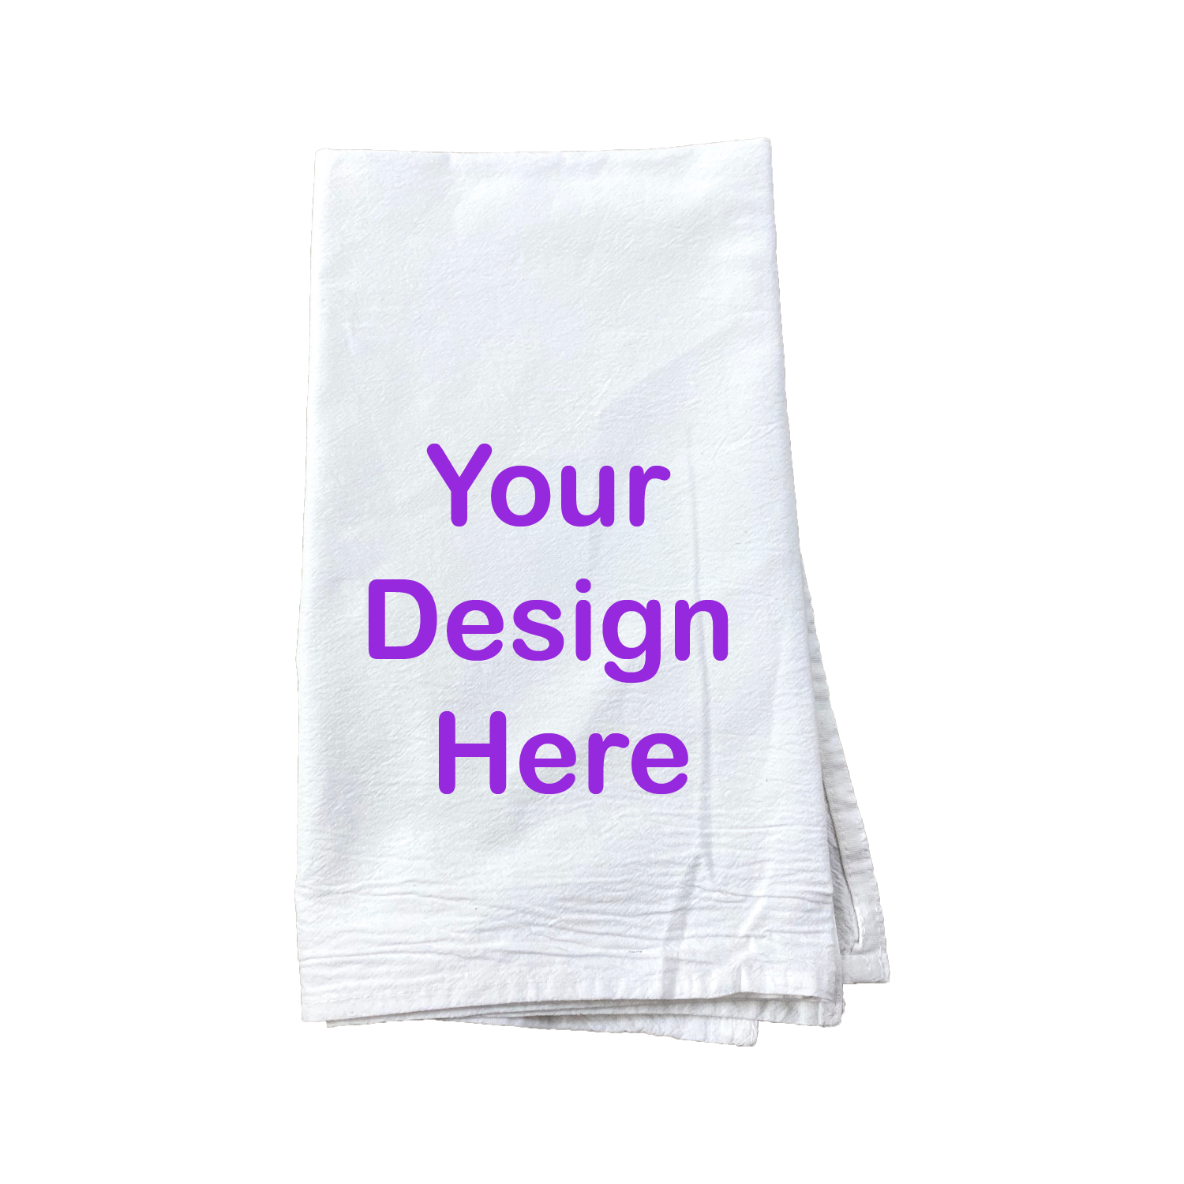
-------------------------------------------------------------------------------

TEA TOWEL ORDER FORM

Student Name: ______________________________________________ Class: ____________

Contact Name _____________________ Phone Number: ____________________________

Number of Tea Towels Ordered: 1 2 3 4 5 6 or more →___________

Please enclose payment with your order: TOTAL enclosed $________
Cash
Check: (made payable to (your organisation name here)
PayPal: send money to (your organisation’s email here)
Please put child’s name as the reference. Lodgement receipt No. ____________

Orders are due back
with payment by:

(order due date) here)

